Join Us to Discuss a Better Way to Measure School Quality
with Dr.Jack Schneider 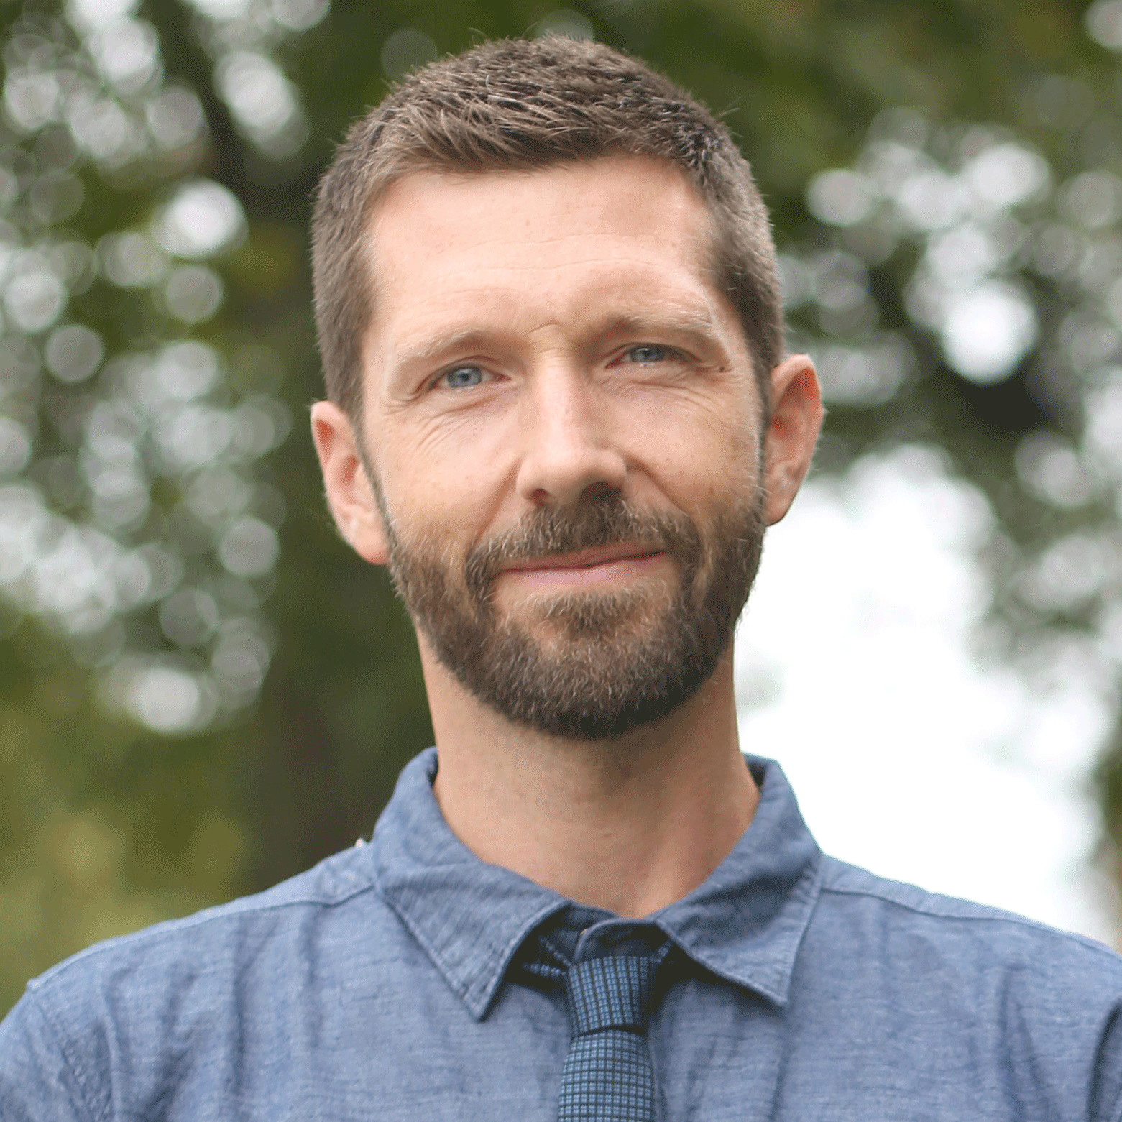
Measuring School Quality: “It’s both about the spirit of a school and helping to restore the full purpose of education, and it’s about actionable information. For students and parents and citizens, who are interested in public education, it’s about getting better at all of the things that we want to get better at, not just in this one narrow area—the acquisition of the academic content in math and English—that often produces unintended consequences like undermining the rest of the curriculum.” Dr. Jack Schneider, author of A Better Way to Measure School Quality; Director of Research for the Massachusetts Consortium for Innovative Education Assessment.

Columbia Heights Education Campus
3101 16th Street Northwest
Washington, DC 20010
January 26, 2019
10:30am to 12:00
Childcare and Translation Available if requested

Register at: https://www.eventbrite.com/e/a-better-way-to-measure-school-quality-tickets-53226810824
Co-Sponsored by the Senior High Alliance of Parents, Principals and Educators; Teaching for Change; Ward 1 Education Group, CHPSPO, EmpowerEd, Ward 4 Education Alliance, Ward 7 Education Council
Contact: dc.shappe@gmail.com

