I am Valerie Jablow, a DC citizen concerned that students and the public were treated poorly by the oversight and closure of Washington Mathematics Science Technology High School.

Problems with the school’s finances were apparent as early as 2014, according to the most recent Financial Audit Review I accessed, released in July 2017. That document also shows that the school’s debt ratio was at or near 1 in recent years.

Also, as shown by 2017 documents the City Paper received via FOIA, even after charter board staff met with school staff in May 2017 and weeks later proposed a fiscal corrective action plan, the school appears not to have been helped nor was a public alarm obviously raised.

Earlier this calendar year, I accessed on the charter board website the school’s 20-year review, dated January 2018. Since then, that review was pulled from the website, and my queries to charter board staff about it have gone unanswered. As I recall, that review recommended continuing operations and was only mildly concerned with the school’s finances.

Recently, a different 20-year review dated March 12, 2018, was added in its place on the website—and raises significant concerns with the school’s finances.

Also, the FOIA documents obtained by City Paper show that charter board members were told that charter board staff began raising concerns about the school’s finances only in late 2017, when it was in fact much earlier in 2017. There were also repeated statements that the school’s main asset—its building—was overvalued at $9 million.

However, the city’s assessment for at least two years is close to $10 million.

With Douglas Development buying up most of that entire city block in May 2017, and recently breaking ground there for a major development, the school’s fate appeared sealed when it was recently ordered to sell its only asset within a month to stay in business. In that time, Douglas bought the school for $6.25 million--significantly less than its assessed value and not leaving enough for the school to continue elsewhere.

Neither the school nor the public appear well-served by such financial oversight, which appears to have led to a rush to close the school with no obvious notification to the public. That also seems to have advantaged the developer at the direct expense of the school and its students.

Thank you.

Accessed May 21, 2018, from this website: http://www.dcpcsb.org/2016-financial-audit-review
I received the FOIA production from Rachel Cohen, the writer of the City Paper article on the closure of WMST: https://www.washingtoncitypaper.com/news/city-desk/article/21002438/the-dc-public-charter-school-board-didnt-intervene-in-a-financially-troubled-school On May 21, 2018, during my public delivery of this testimony, I handed the complete FOIA production to the charter board via thumb drive.
I have attempted to find any notices of concern for the fiscal state of WMST and was unable to find any on the charter board website.
In late February or early March 2018, I accessed this January 2018 20-year review document from the website page where all charter reviews and renewals are housed: http://www.dcpcsb.org/report/charter-reviews-and-renewals-0 The only review for WMST as of May 21, 2018 available there is from 2013.
On Friday, April 27, 2018, I spoke to PCSB staffer Laterica Quinn, who said that the PCSB staffer in charge of reviews had recently left employment there and that she was in charge of reviews and would look into it. I then called WMST and left a message as well as sent emails to some staff there and its board, asking if they had the January 2018 review and could send it to me. I also left a message with the WMST lawyer, who appeared before the charter board at the recent revocation hearing. I have not yet obtained a response from them on this. Also, see the footnote immediately below for further communications on this.
On Friday 4/27/18, I sent an email to Tomeika Bowden, chief communications officer for PCSB, asking about the January 2018 20-year review. She responded on Monday 4/30/18 and sent me a link to the March 12, 2018 document. When I asked her where the January document was, she did not respond. The March 12, 2018 20-year review appears not to be available on the website of charter reviews and renewals. Instead, it is in the materials for the March 12 emergency charter board meeting on WMST. (See here: http://www.livebinders.com/play/play?id=2345731). That same version of the school’s 20-year review is also linked in a document (dated 4/23/18) created by PCSB executive director Scott Pearson for the April 23, 2018 board meeting, recommending that the board vote revoke the school’s charter (in footnote 5 of that document, available here: http://www.livebinders.com/media/get/MTc2NTUzNDU=). Nonetheless, the January 2018 20-year review clearly once existed. Starting on p. 315 of the FOIA materials, there are a number of emails dating from December 2017 with “January review reports” contained in the subject line. All the information about those reports (as well as what appeared to have been the draft report itself on WMST) is blacked-out, presumably because they represent a “deliberative discussion.” However, it’s not clear to me how a draft report represents a “deliberative discussion." On page 428 of the FOIA materials, there is an email dating from 1/17/18 from PCSB staffer Taunya Nesin, who gives a link to the January 2018 20-year review. But when I accessed that document online (at the link provided by Nesin: https://dcpcsb.egnyte.com/dl/DGlOHXb6bC), it went directly to the March 12, 2018 20-year review. Given that the email with that link was sent in mid-January 2018, there would have been no way for the document it linked to therein to have been dated March 12, 2018. In other words, the January review that it once originally linked to has been removed and replaced with the March document. My recollection that the January 2018 20-year review seemed to make WMST’s financial difficulties less urgent appears supported by a March 4 email on p. 623 of the FOIA materials. In the email to the PCSB executive director, charter board member Don Soifer said (boldface mine) “I appreciate your candor regarding what we might have seen and acted on earlier. When we undertook the WMST review in January there were shortfalls identified and discussed in that process that it’s tempting to see now as warning signs. But the timeframe we felt for any potential default based on the information before us then would have at least gotten us through the end of the year.”
As the City Paper story outlined, the FOIA materials also appear to show that PCSB executive director Scott Pearson misrepresented PCSB staff actions, with regard to WMST finances, to charter board members. Specifically, on p. 589 of the FOIA materials, Pearson sent an email to charter board members on 3/3/18, noting that a PCSB staffer had flagged WMST for scrutiny “late last year” (i.e., in late 2017). But the FOIA materials make clear that the same PCSB staffer, Mohammad Bashshiti, had raised many concerns with the school’s finances well before then and even met with WMST staff on that subject on May 10, 2017. Notes of that meeting (referenced on p. 24 of the FOIA materials) are here: https://dcpcsb.egnyte.com/dl/62RAoEspdA.
The assessment is available online, in the city’s database: https://www.taxpayerservicecenter.com/RP_Search.jsp?search_type=Assessment I accessed this on May 21, 2018, and it shows the value for that property close to $10 million; I have put below a screenshot from May 21, 2018: 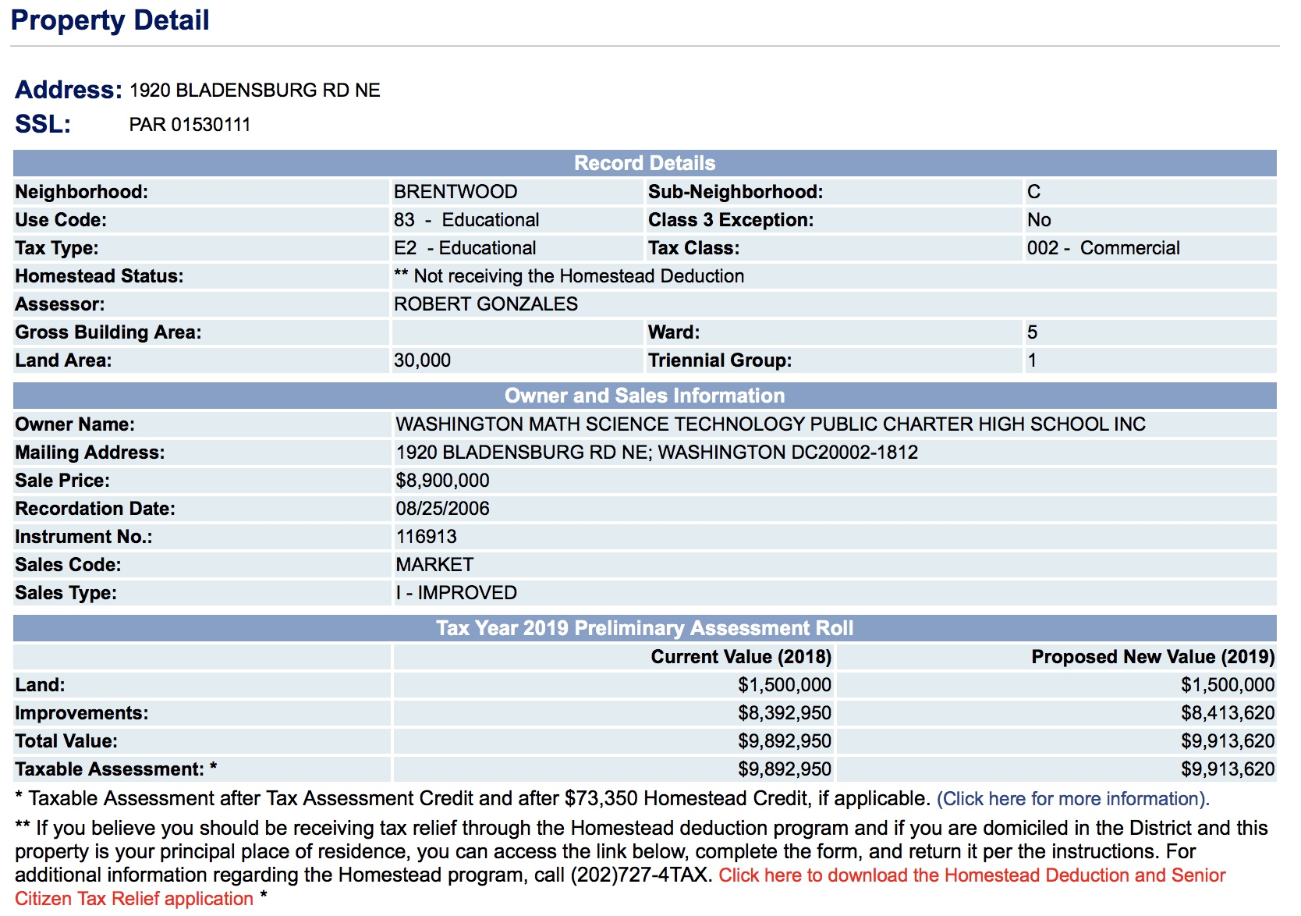
A day after PCSB staff met with WMST staff on the school’s financials (5/10/17), on May 11, 2017, an LLC under the auspices of Douglas Development purchased many parcels of land on that same block immediately around WMST’s building. The purchase of those parcels for $66 million ensured that nearly the entire city block bounded by New York Avenue, Bladensburg Road, and Montana Avenue was owned by that company or LLCs connected to it. In fact, the only parcels on that block not owned by Douglas in May 2017 were WMST and a fast food restaurant on the corner of NY Ave. and Bladensburg Rd. Because the school is surrounded by Douglas-owned land, it was the only thing on that block that would have impeded a contiguous Douglas development there. Years before, under a different owner, some (possibly all) of that land purchased by Douglas on 5/11/17 had been intended as a Wal Mart, which the store eventually pulled out of. (See story here: https://www.washingtonpost.com/business/capitalbusiness/site-where-wal-mart-plans-store-on-new-york-avenue-in-dc-goes-up-for-sale/2014/01/14/8937e16a-7c69-11e3-95c6-0a7aa80874bc_story.html?utm_term=.6947ed355289) After the 5/11/17 purchase by Douglas, local news stories highlighted the developer's plans for what was clearly intended to be a major development on that city block (see one here: https://www.bisnow.com/washington-dc/news/mixed-use/douglas-development-buys-newcitydc-site-for-66m-74404).
This is documented by way of charter board meetings in April regarding the closure of the school. In the video of a meeting at WMST with PCSB on April 5, 2018, an accounting professional notes that WMST had agreed to sell its property for $6.25 million to the Douglas development company (see here, https://livestream.com/accounts/6219837/events/8144866, starting at minute 19:30—unfortunately, as of 5/21/18, I am unable to access this video. The video link is available here on the website for that meeting: http://www.dcpcsb.org/event/public-hearing-washington-mathematics-science-technology-pcs; but the link to the video itself doesn’t provide anything. The video, however, clearly once existed and was available there.). The Douglas purchase price, however, was insufficient to bail WMST out—even with an apparent agreement in place (as explained in the video) such that the school would pay no rent for 12 months and stay in that location. The school had purchased the property in 2006 for $8.9 million. Although what WMST would net with the $6.25 million purchase price would match the school's outstanding loan, the school would not have enough money left to stay in existence. That $6.25 million purchase price is well below the DC assessment for that property, which is closer to $10 million than $9 million (see footnote above with screenshot).

